Benjamin Hanim

The decision to construct a linear regression model initially stems from its simplicity and interpretability, making it an ideal baseline for comparing against more complex machine learning approaches. By establishing this baseline, we can assess the added value of machine learning techniques in capturing the intricate patterns inherent in stock price data.

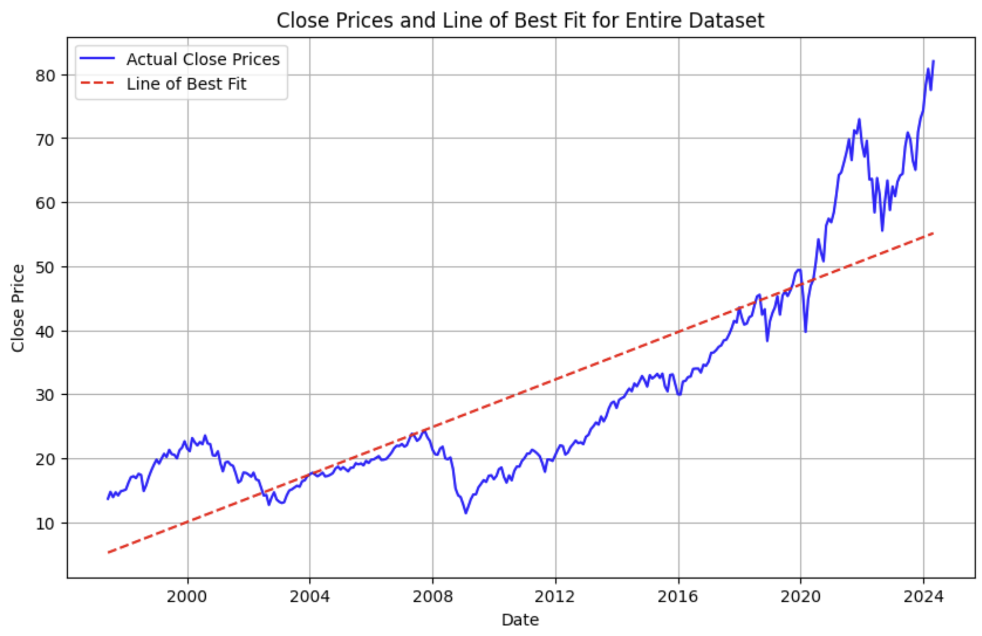

Accounting for the start point and extending the linear regression slope to the 12th last month ensures that the model adapts to recent trends, enhancing its relevance for comparison with machine learning models. This adjustment aligns the model's trajectory with the most recent historical data, providing a more accurate representation of recent stock price movements.

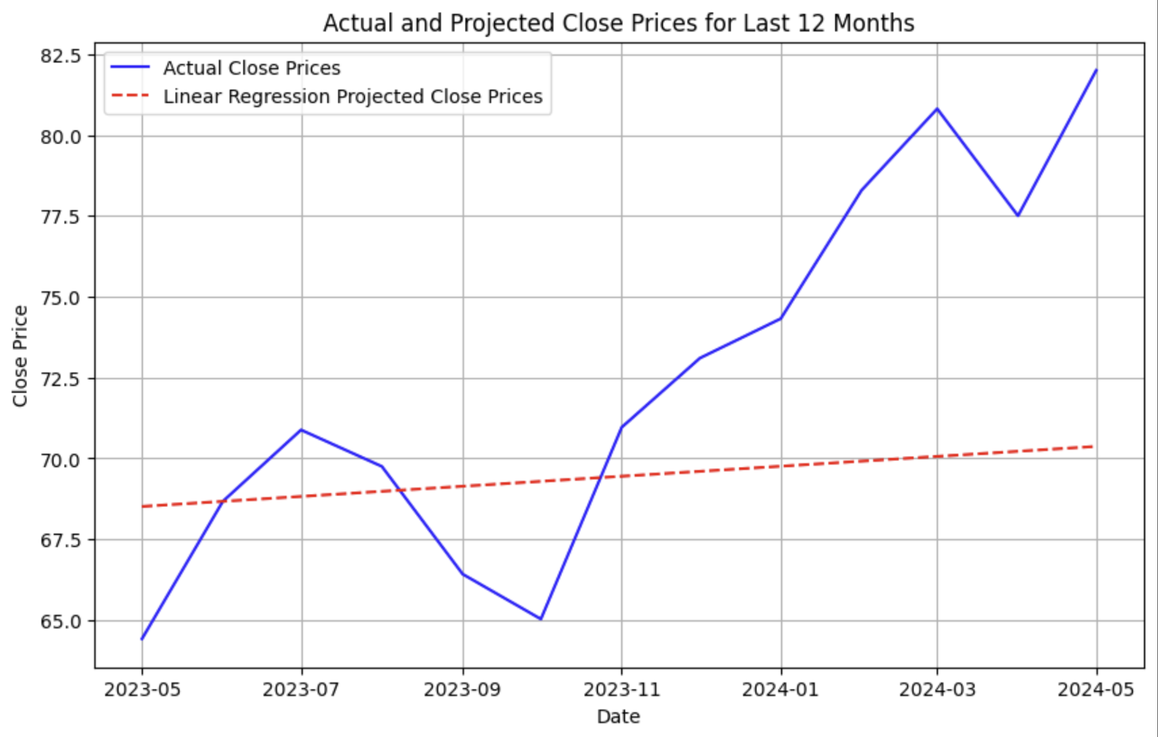

The relative Mean Absolute Error (MAE) of 6.5% for the linear regression model serves as a crucial performance metric, indicating its efficacy in forecasting the last 12 months of stock prices. This metric sets a baseline against which the performance of machine learning models can be evaluated, offering valuable insights into their effectiveness.

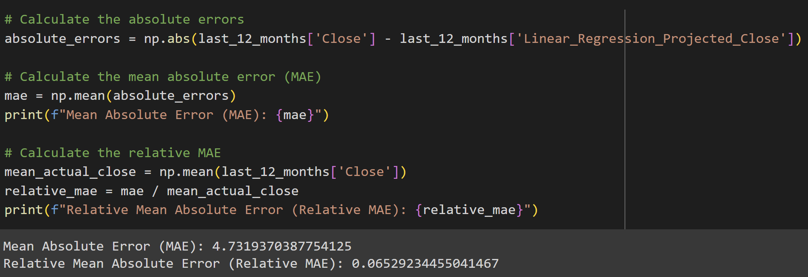

The structure of the neural network employed in the machine learning model is carefully designed to capture complex patterns in the stock price data. With two LSTM layers—one with 100 units and the other with 50 units—the network can effectively learn intricate temporal dependencies and nonlinear relationships within the data. By incorporating the relu activation function and employing the Adam optimizer, the model can efficiently optimize its parameters and minimize the mean absolute error loss function. This architecture enables the neural network to effectively extract meaningful features from the input data and generate accurate predictions of future stock prices.

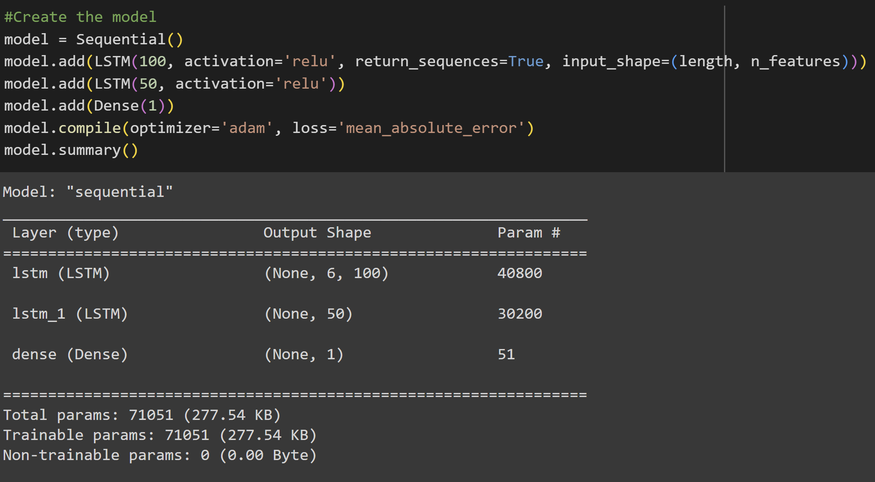

In order to mitigate the risk of overfitting, the decision to keep the number of epochs low in the training process of the machine learning model is strategic. By limiting the epochs, we aim to prevent the model from memorizing the training data too closely and instead encourage it to generalize well to unseen data. This cautious approach helps maintain the model's ability to make accurate predictions on new data points, thereby enhancing its reliability and applicability in real-world scenarios.

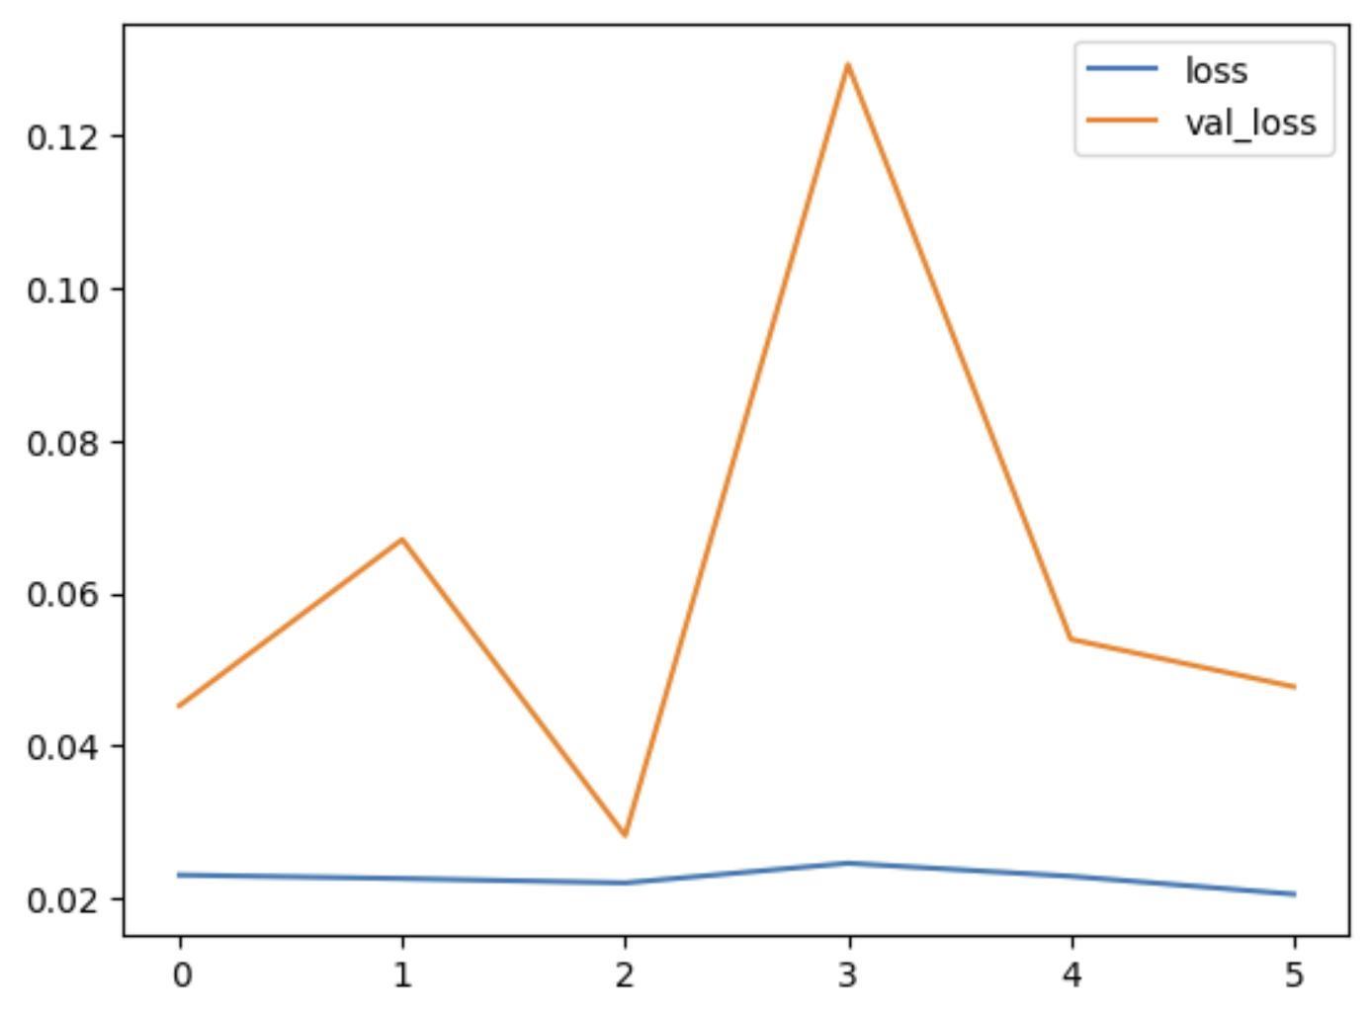

Test predictions achieved:

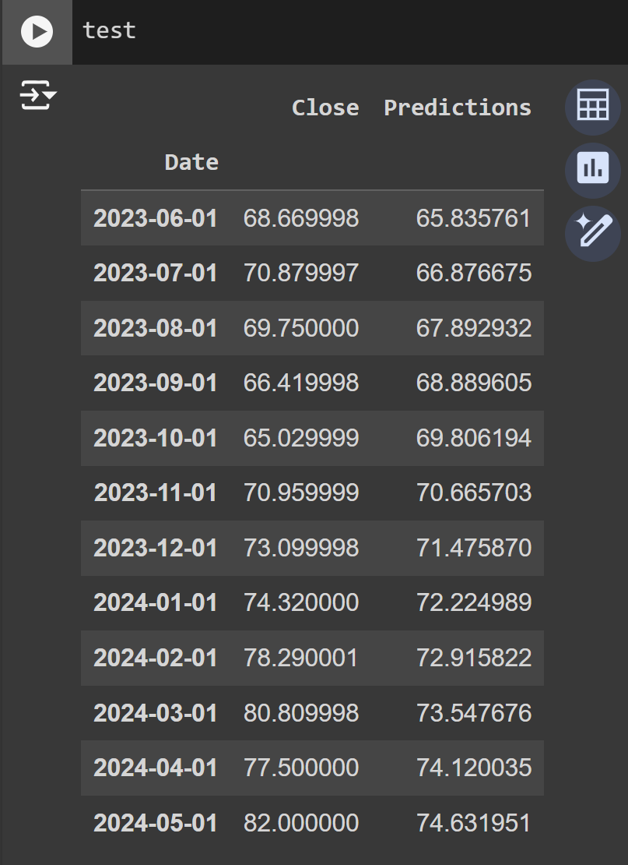

In contrast, initializing a machine learning model specifically to predict the last 12 months allows for more sophisticated analysis, capturing nonlinear relationships and intricate patterns in the data. Achieving a relative MAE of 4.9% with this model highlights its superior performance compared to the linear regression approach. Notably, the machine learning model's predictions closely mirror actual stock prices, underscoring its ability to capture subtle nuances in market dynamics.

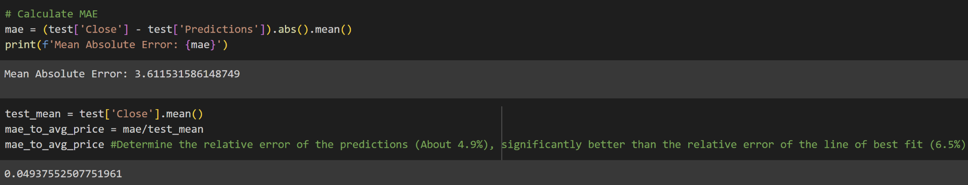

We can see that the graph models the shape of the actual stock better than the line of best fit.

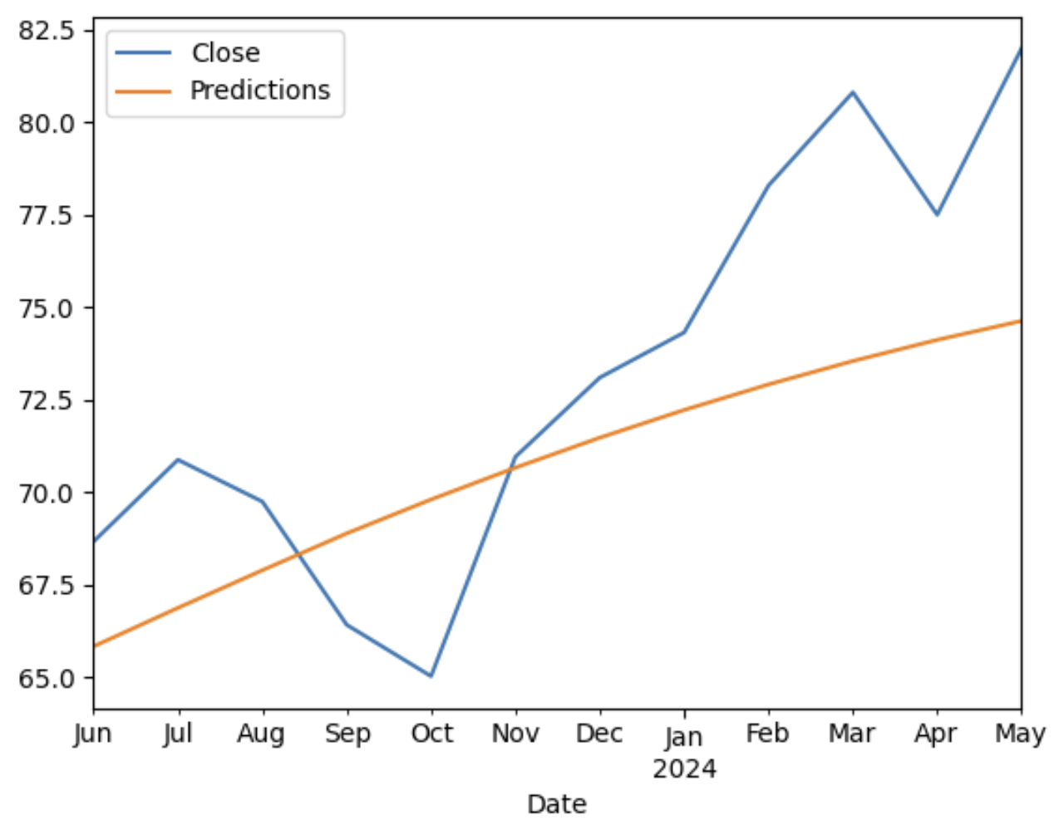

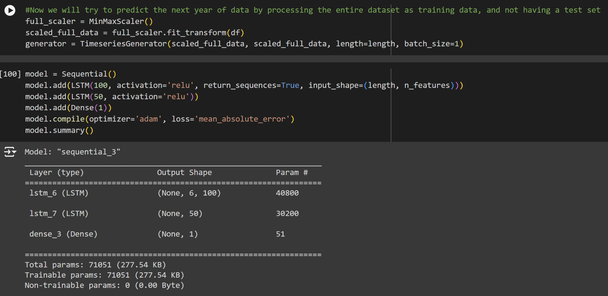

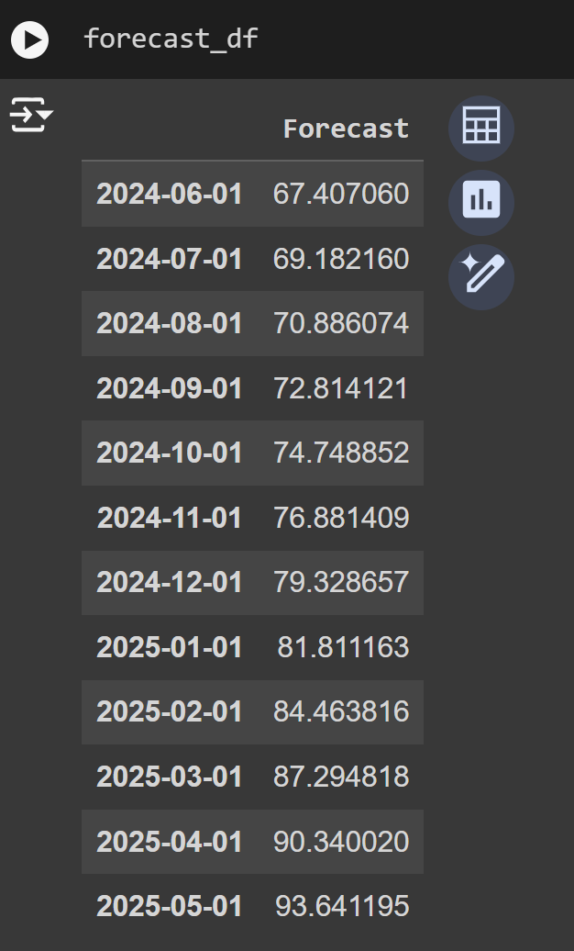

Looking forward, the machine learning model's forecast provides valuable insights into future trends in stock prices. For instance, the anticipation of a probable dip in the coming month following a recent surge, followed by a subsequent upward trend, reflects the model's capacity to discern complex market dynamics and provide actionable insights for investors.

